**I. Cost Report Outline**

1. Cover Sheet
2. Table of Contents
3. Summary of Materials/Cost per System
4. 8 Commodity Reports (One for each system, determined by FSAE)
   1. Bill of Materials: A cascading list of system, sub assemblies, parts, then the materials, processes, and fastners needed to complete the part. Should include things like jigs and prototyping. These would go in the intial cost (ie probably wouldn't scale with each additional car)
5. A t the specific level, there should be a cost assosciated with each material, process, fastner. These should scale. We are looking at 1000 cars.
   1. Be based on the real process that we used to make the parts
   2. Cost is found using look up tables provided by FSAE
6. Should include cost for 1 car and cost for 1000 cars
7. Do include stuff like tooling (welding, jigging, energy to run tools, cutting instruments, die’s molds) and labor
8. Exclude R and D and capital expenditures from the report (things like space/rent, machines, power tools, hand tools)
9. Examples can be found on FSAE online

**II. Goals for Tuesday 3-08**

1. Bill of materials for all mechanical systems of the car (example of BOM in appendix)
2. Start BOM for electrical system
3. Plan future goals/work

**III. Appendix**

1. Bill of Materials

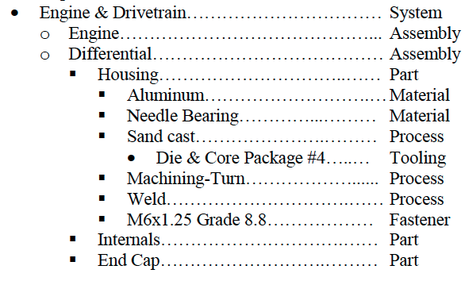

We should include more specific information (quantity and size/shape) so that cost look up later is simpler

1. Sample Reports